## Image result for krct logo

## IMPLEMENTATION OF A DC MOTORSPEEDCONTROLLER USING IC555 FOR PRECISION CONTROL

**ECB1204 - ANALOG INTEGRATED CIRCUIT**

## A PROJECT REPORT

***Submitted by***

# SAI SHACKTHI S

# MURALI KRISHNANA T

# PRAGADEESHWARAN RR

***in partial fulfillment for the award of the degree of***

# BACHELOR OF ENGINEERING

***in***

# ELECTRONICS AND COMMUNICATION ENGINEERING

**K. RAMAKRISHNAN COLLEGE OF TECHNOLOGY**

(An Autonomous Institution, Affiliated to Anna University Chennai and Approved by AICTE, New Delhi)

## SAMAYAPURAM, TIRUCHIRAPPALLI – 621 112

**DECEMBER, 2024**

# K. RAMAKRISHNAN COLLEGE OF TECHNOLOGY (AUTONOMOUS)

**SAMAYAPURAM, TIRUCHIRAPPALLI– 621 112**

# BONAFIDE CERTIFICATE

Certified that this project report titled **SAI SHACKTHI S (2303811710621092),MURALI KRISHNAN T (2303811710621073),PRAGADEESHWARAN RR(2303811710621079),** who carried out the project under my supervision. Certified further, that to the best of my knowledge the work reported herein does not from part of any other project report or dissertation on the basis of which a degree or award was conferred on an earlier occasion on this or any other candidate.

|  |  |
| --- | --- |
| **SIGNATURE**  Dr. S. SYEDAKBAR, M.E., Ph.D.,  **HEAD OF THE DEPARTMENT**  Assistant Professor  Department of Electronics and Communication Engineering  K Ramakrishnan College of Technology (Autonomous)  Samayapuram – 621 112 | **SIGNATURE**  Mrs. G. KEERTHANA, M.E.  **SUPERVISOR**  Assistant Professor  Department of Electronics and Communication Engineering  K Ramakrishnan College of Technology (Autonomous)  Samayapuram – 621 112 |

Submitted for the viva-voce examination held on ………………

**INTERNAL EXAMINER EXTERNAL EXAMINER**

# DECLARATION

We jointly declare that the project report on **“DC MOTOR SPEED CONTROLLER CIRCUIT”** is the result of original work done by us and best of our knowledge, similar work has not been submitted to **“ANNA UNIVERSITY CHENNAI”** for the requirement of Degree of **BACHELOR OF ENGINEERING**. This project report is submitted on the partial fulfillment of the requirement of the award of Degree of **BACHELOR OF ENGINEERING**.

### Signature

SAI SHACKTHI S

#### MURALI KRISHNAN T

PRAGADEESHWARAN RR

Place: Samayapuram Date :

iii

# ACKNOWLEDGEMENT

It is with great pride that we express our gratitude and in-debt to our institution

**K. Ramakrishnan College of Technology (Autonomous)**, for providing us with the opportunity to do this project.

We are glad to credit honorable and admirable chairman **Dr. K. RAMAKRISHNAN**, **B.E.,** for having provided the facilities during the course of our study in college.

We would like to express our sincere thanks to our beloved Executive Director **Dr. S. KUPPUSAMY, MBA, Ph.D.,** for forwarding our project and offering adequate duration in completing our project.

We would like to thank **Dr. N. VASUDEVAN, M.Tech., Ph.D.,** Principal, who gave us the opportunity to frame the project with full satisfaction.

We wholeheartedly thank **Dr. S. SYEDAKBAR, M.E., Ph.D.,** Head of the Department, Department of Electronics and Communication Engineering for providing his encouragement in pursuing this project.

We express our deep and sincere gratitude to our project guide **Mrs.G.KEERTHANA, M.E.,** Assistant Professor, Department of Electronics and Communication Engineering, for her incalculable suggestions, creativity, assistance and patience which motivated us to carry out this project.

We wish to express my special thanks to the officials and Lab Technicians of our department.

**TABLE OF CONTENTS**

**CHAPTER NO. TITLE PAGE NO.**

1. PROBLEM STATEMENT 1
   1. BACKGROUND OF THE WORK 1
2. DESIGN PROCEDURE OF DC MOTOR SPEED 2 CONTROLLER
   1. DESIGN MODULE 2
      1. PWM SIGNAL GENRETION MODULE 2
      2. DUTY CYCLE ADJUSTMENT MODULE 3
      3. SWITCHING MODULE 3
      4. LOAD MODULE 4
      5. POWER SUPPLY MODULE 4
      6. PROTECTION AND STABILIZATION

MODULE 5

2.1.7 MOTOR CONTROL 5

* 1. WORKING OF THE DC MOTOR SPEED 6

CONTROLLER

* 1. INTERNAL PROCESS 6

### 2.4 CALCULATION OF DC MOTOR SPEED 7

### CONTROLLER

### 2.5 TESTING AND ADJUSTMENT OF THE CIRCUIT 8

3 COST OF THE COMPONENTS 9

3.1 PRIZE OF THE COMPONENTS 9

3.2 PROOF OF COST 10

**4 RESULT AND DISCUSSION** 11

4.2 APPLICATION 13

4.3 ADVANTAGES 14

5 CONCLUSION 15

## CHAPTER 1

## PROBLEM STATEMENT

The efficient control of DC motor speed is a critical challenge in various fields such as robotics, industrial automation, electric vehicles, and household appliances. Traditional speed control techniques, such as variable resistors or mechanical systems, are not only inefficient but also waste energy as heat. This results in reduced overall system performance and shorter operational lifetimes for the components. In applications where precision is key, such as conveyor systems or robotic arms, maintaining consistent speed under varying load conditions becomes a significant issue. Additionally, the need for compact, cost-effective, and energy-efficient solutions further complicates the design process, especially for small-scale and portable systems. These constraints highlight the necessity for a versatile and energy-efficient method to regulate DC motor speed in a reliable and precise manner.

## 1.1. BACKGROUND OF THE WORK

Pulse Width Modulation (PWM) has emerged as a highly efficient and widely used technique for DC motor speed control. PWM achieves speed regulation by adjusting the duty cycle of a square wave signal, which in turn controls the average voltage delivered to the motor. Unlike traditional methods, PWM minimizes energy loss by rapidly switching the motor's power on and off, maintaining a high-efficiency operation. The circuit under consideration leverages a 555 timer IC configured in astable mode to generate a PWM signal. The duty cycle of the signal can be adjusted using a variable resistor, providing precise control over the motor's speed. Additionally, a MOSFET is used as a high-efficiency switch to handle the significant current requirements of the motor. This simple yet powerful design ensures compatibility with a wide range of DC motors and operating voltages (6–16V). The circuit’s adaptability, low cost, and energy efficiency make it suitable for numerous applications, from hobbyist projects to professional systems. By incorporating PWM-based control.

**CHAPTER 2**

**DESIGN PROCEDURE OF DC MOTOR SPEED CONTROLLER**



Figure 2.1 Circuit design of DC motor speed controller

## DESIGN MODULE

## PWM Signal Generation Module

## This module generates a square wave with a variable duty cycle using a 555 timer IC configured in astable mode. The duty cycle determines the motor's speed by controlling the average power delivered to it. To provide the base PWM signal for motor speed control.

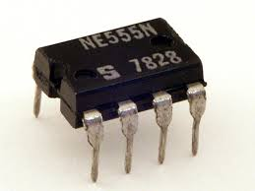

**Figure 2.1 IC 555 Timer**

## Duty Cycle Adjustment Module

## This module allows the user to manually vary the duty cycle of the PWM signal by adjusting a variable resistor,To control the motor's speed by changing the "on" time of the PWM signal.

**Figure 2.2 Variable Resistor**

## 2.1.3 Switching Module

This module uses a power MOSFET (IRF540) as a switch to apply the PWM-controlled power signal to the motor. A gate resistor ensures smooth and controlled switching of the MOSFET. To amplify the low-power PWM signal and drive the high-current motor efficiently.

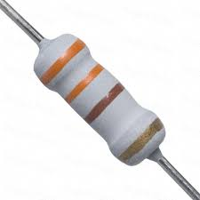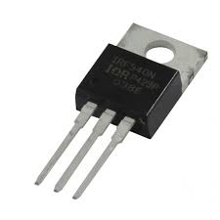

**F**igure 2.3 Capacitor & MOSFET

## 2.1.4 Load Module

This module is the DC motor itself, which acts as the load. The motor’s speed is controlled by the PWM signal, which modulates the average voltage applied.To perform the mechanical operation (e.g., rotation) as required by the application.

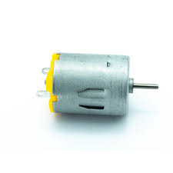

**Figure 2.4 DC motor**

## 2.1.5 Power Supply Module

This module provides the necessary voltage and current to power the circuit and the motor. It supports a range of input voltages from 6–16V. To energize the circuit and ensure stable operation.

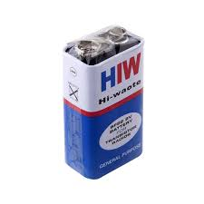

**Figure 2.5 9v Battery**

## 2.1.6 Protection and Stabilization Module

This module includes capacitors and diodes that stabilize the PWM signal and protect the circuit components from voltage spikes and reverse currents.

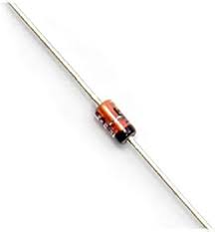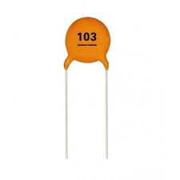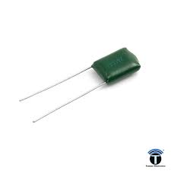

**Figure 2.6 Capacitors , Diode**

**2.1.7 Motor Control**

The motor control is achieved using Pulse Width Modulation (PWM), where a 555 timer generates a square wave with an adjustable duty cycle. The duty cycle, controlled by a variable resistor, determines the average voltage supplied to the motor. A power MOSFET switches this PWM signal to drive the motor efficiently, regulating its speed.

* 1. **WORKING OF THE DC MOTOR SPEED CONTROLLER**

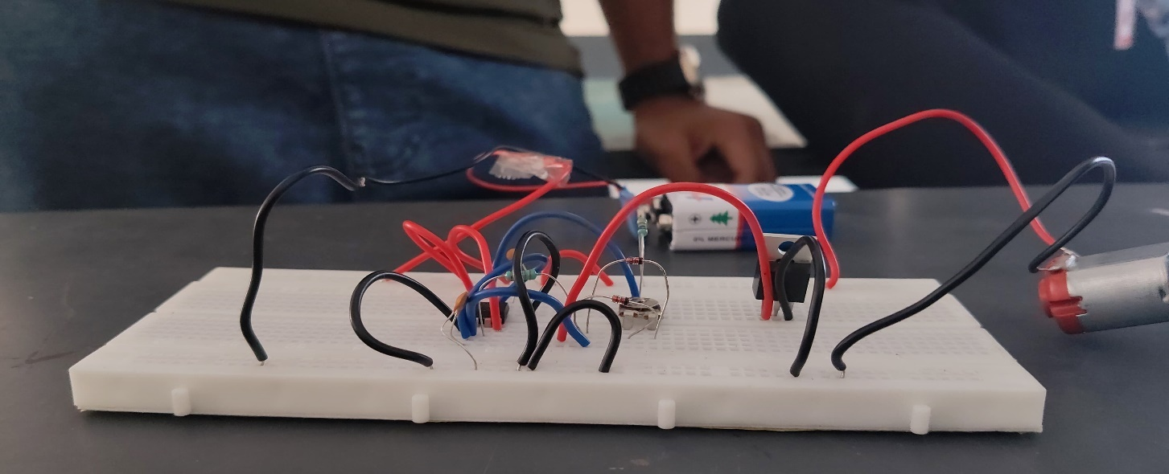

**Figure 2.7 Working Model of DC motor Speed Controller**

### 

### INTERNAL PROCESS

The PWM-based DC motor speed control circuit operates through a systematic internal process, beginning with the generation of a PWM signal using a 555 timer IC configured in astable mode. This timer produces a continuous square wave output, where the duty cycle—the proportion of time the signal stays high—can be adjusted to regulate the motor speed. The timing of this signal is determined by the interplay of resistors, capacitors, and diodes in the circuit. The variable resistor (100 kΩ) is particularly significant as it allows the user to modify the charging and discharging cycle of the timing capacitor (104), thereby

controlling the duty cycle. A higher duty cycle corresponds to a longer "on" time for the motor, increasing its speed, while a lower duty cycle results in reduced speed.

The PWM signal generated by the 555 timer is directed to the gate of the IRF540 power MOSFET via a gate resistor (330 Ω). The MOSFET functions as a high-current switch, translating the low-power PWM signal into a high-power signal suitable for driving the DC motor. This process ensures efficient energy transfer to the motor with minimal heat dissipation, making it highly effective for power-sensitive applications. The motor, connected to the MOSFET's drain terminal, operates at a speed proportional to the average voltage determined by the PWM duty cycle. The continuous switching action ensures that the motor receives controlled bursts of power, optimizing its performance.

### CALCULATION OF DC MOTOR SPEED CONTROLLER

**2.5 Testing and adjusting of the circuit**

Testing begins by verifying connections and monitoring the PWM signal output from the 555 timer. Adjusting the variable resistor changes the duty cycle, controlling motor speed. After connecting the motor, its behavior is tested under load, ensuring stability and consistent operation. Components are monitored for heat, and adjustments are made for optimal performance.

## CHAPTER 3

**COST OF THE COMPONENT**

## 

Table 3.1 Cost and Quantity of the Components Used

|  |  |  |
| --- | --- | --- |
| **SI.NO** | **APPARATUS REQUIRED** | **COST (INR)** |
| 1 | IC 555 TIMER | 100 |
| 2 | 100 KΩ VARIABLE RESISTOR | 10 |
| 3 | IRF 540 MOSFET | 25 |
| 4 | DC MOTOR | 30 |
| 5 | 9V BATTERY | 30 |
| 6 | BREAD BOARD | 100 |
| 7 | CONNECTING WIRE | 50 |
|  | **TOTAL** | **415** |

## PROOF OF COST

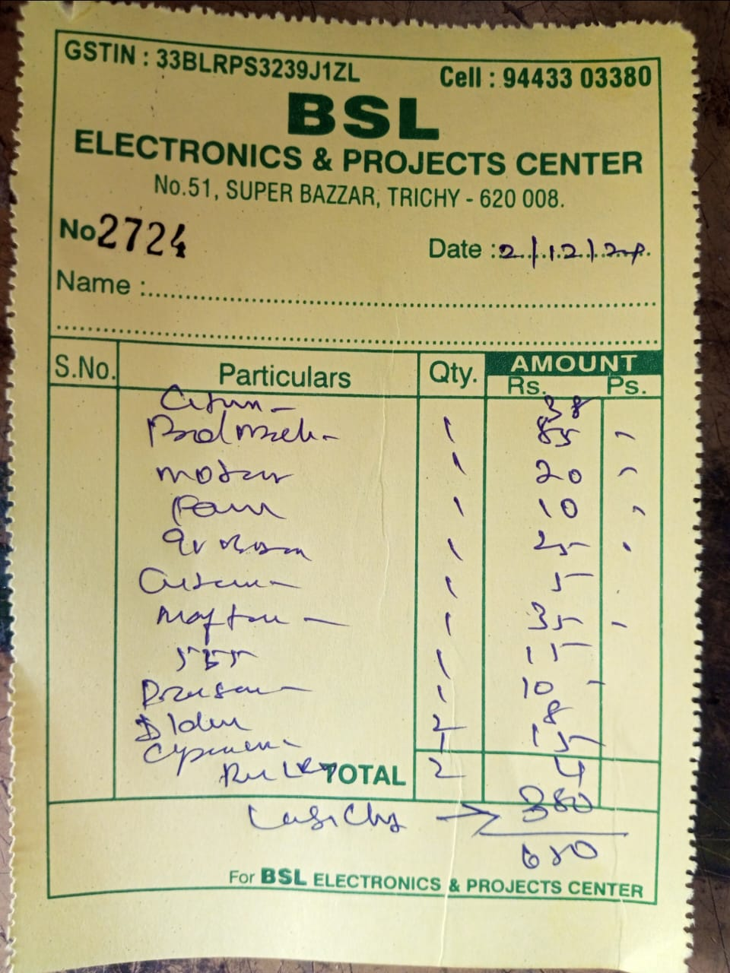

Figure 3.1 Components Bill Image

## CHAPTER 4 RESULT AND DISCUSSION

The results of the experiment highlight several key aspects of using the 555 timer for DC motor speed control. First, the simplicity of the design and ease of adjustment are significant advantages. By merely altering the resistor and capacitor values, the motor speed can be finely tuned to meet the required performance specifications. This makes the system highly adaptable for various applications, from hobbyist projects to industrial machines.

Moreover, the use of PWM control ensures that the motor operates efficiently, with minimal power loss. Since the motor is not subjected to continuous full voltage, the energy is used more effectively, reducing heat generation and extending the motor’s lifespan. Additionally, the system provides smoother control compared to simple voltage regulation methods, making it ideal for applications requiring precise speed adjustments.

In terms of limitations, the 555 timer's frequency range is relatively narrow, which may restrict its use in applications requiring very high-speed adjustments. For high-power applications or motors with complex control requirements, a more advanced control system may be needed. However, for most small- to medium-sized DC motors, the 555 timer-based PWM control provides an efficient and effective solution.

The system's versatility was also evident in the variety of potential applications, including robotics, fans, conveyor belts, and electric vehicles. The ability to easily integrate this speed control method into a wide range of devices, coupled with its low cost, makes it a suitable choice for many practical uses.

In conclusion, the 555 timer IC offers an excellent balance of simplicity, cost-effectiveness, and performance for controlling the speed of DC motors. The results from the experiment support its use in various applications where adjustable motor speed is necessary, and its PWM functionality ensures efficient and reliable operation across a broad spectrum of conditions.The implementation of DC motor speed control using the 555 timer IC in PWM (Pulse Width Modulation) mode was successfully achieved, with the motor's speed being directly controlled by varying the duty cycle of the PWM signal. The system was tested with a simple setup consisting of a 555 timer, a transistor (or MOSFET), and a DC motor. By adjusting the resistors and capacitors connected to the 555 timer, the frequency and duty cycle of the PWM signal were modulated, leading to a corresponding change in the motor's speed.

As expected, when the duty cycle was increased, the motor speed increased, and conversely, a lower duty cycle resulted in a decrease in motor speed. The speed adjustment was smooth, and the system showed stable performance without significant fluctuations or overheating, demonstrating the efficiency of the PWM control. Furthermore, the circuit was able to operate reliably under different load conditions, confirming the versatility and stability of the 555 timer in motor speed control

### APPLICATION

In terms of applications, the 555 timer IC-based speed control is used in a wide range of fields. In robotics, it helps control the speed of motors for wheels and actuators, enabling precise movement. It is also widely used in fans, where it allows for adjusting airflow by controlling the fan speed. In electric vehicles, the 555 timer can be employed for regulating motor speed, improving energy efficiency and performance. Other common applications include model trains, conveyor belts, power tools, and home appliances like hairdryers and coolers, where varying motor speeds are essential for efficient operation. The simplicity, low cost, and versatility of the 555 timer make it an ideal solution for both hobbyists and industrial applications that require DC motor speed control.

### ADVANTAGES

DC motor speed control using the 555 timer IC offers several advantages, including cost-effectiveness, simplicity, and flexibility. The 555 timer is an inexpensive and widely available component, making it an ideal choice for budget-friendly projects. It is easy to implement, requiring only a few additional components, which makes it accessible even for beginners. The 555 timer operates in Pulse Width Modulation (PWM) mode, allowing precise control over motor speed by adjusting the duty cycle of the PWM signal. This method ensures efficient motor operation with minimal power loss and heat generation. Additionally, the 555 timer is low-power, compact, and reliable, making it suitable for a variety of applications. Its speed control capabilities are adjustable, providing flexibility for different motor types and system requirements.

### CHAPTER 5 CONCLUSION

In Conclusion, The project on DC Motor Speed Control using the 555 Timer IC has proven to be an insightful and practical exploration into the world of electronics and motor control. Through the successful implementation of a PWM-based control system, this project highlights the effectiveness, efficiency, and versatility of the 555 Timer IC in real-world applications. The project successfully demonstrated the use of PWM (Pulse Width Modulation) to control the speed of a DC motor. By adjusting the duty cycle of the PWM signal, the motor's speed was regulated smoothly and precisely, showcasing the practical utility of the 555 Timer IC in motor control applications. This project served as an excellent educational tool, providing hands-on experience in circuit design, PWM generation, and practical application of electronic components. Participants gained a deeper understanding of the principles of PWM and the operational intricacies of the 555 Timer IC. The use of PWM ensured minimal power loss, making the system energy-efficient. Additionally, the 555 Timer IC and other components used were inexpensive and readily available, demonstrating a cost-effective approach to achieving motor speed control. The project underscored the importance of motor speed control in various fields such as industrial automation, robotics, and consumer electronics. The ability to precisely control motor speed is crucial for optimizing performance and ensuring smooth operation in these applications.